# Lab: Mass Effect

This document defines a lab assignment from the ["OOP" Course @ Software University](https://softuni.bg/courses/oop/).

Mass Effect is a video game where **starships** can **travel from one star system to another** and **attack other ships**. You are given a skeleton (partially written code) for the game as well as a problem description. Your task is to finish the game by applying the best practices of OOP. You can test your solution in the automated Judge system [here](https://judge.softuni.bg/Contests/93/OOP-Retake-Exam-1-June-2015).

### Step 1 - Read the Problem Description

Read the given problem description to better understand the problem.

### Step 2 - Study the Code

Being able to find your way around someone else's code is a very important skill. Let's study the provided classes in the skeleton one by one:

* Engine
  + **GameEngine** - implements the IGameEngine interface. The **Run()** method starts a while loop until its **IsRunning** property yields false. It reads a **string command** from the console and passes it to the **ProcessCommand()** method of its CommandManager. A **try-catch** block ensures that any **ShipException** that might occurr in **ProcessCommand()** will be properly handled.
  + **CommandManager** - keeps all commands in a dictionary where the key is the command as a string (e.g. "attack") and the value is the instance of the corresponding command (e.g. **new AttackCommand()**);   
    **ProcessCommand()** retrieves a command from the dictionary and calls its **Execute()** method:  
    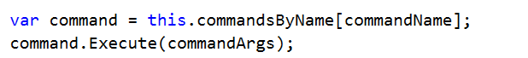
  + Commands - **none** of the commands are implemented
    - **Command** - base class for any command; holds a reference to an IGameEngine and an empty **Execute()** method.
    - **AttackCommand** - encapsulates logic for executing an attack
    - **CreateCommand** - encapsulates logic for creating a ship
    - **OverCommand** - encapsulates logic for stopping the game engine
    - **PlotJumpCommand** - encapsulates logic for changing the location of a ship
    - **StatusReportCommand** - encapsulates logic for displaying info about a ship
  + Factories
    - **ShipFactory -** holds method **CreateShip()** that creates a ship, given a type, name and location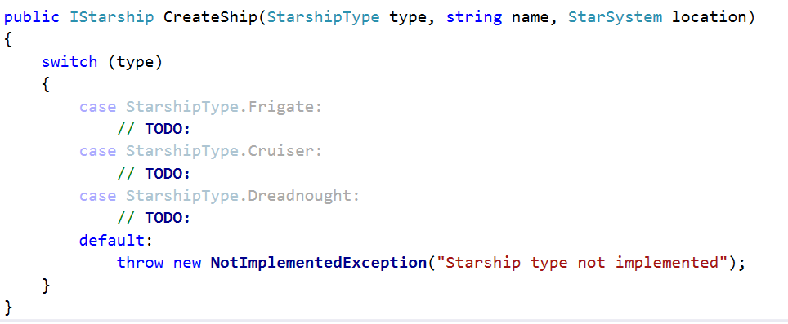
    - **EnhancementFactory -** holds method **Create()** that creates an enhancement, given a type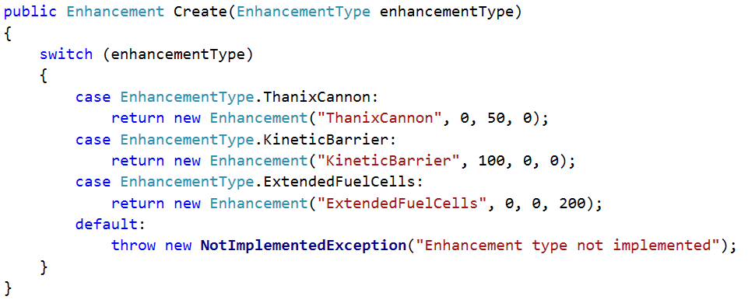
  + **Messages** - a static class that holds **messages** as public **constants**, available for use in the entire application
* Exceptions - the namespace holds **custom exception classes**
  + **ShipException**
  + **InsufficientFuelException**
  + **LocationOutOfRangeException**
* GameObjects
  + Enhancements
    - **Enhancement** - holds **ShieldBonus**, **DamageBounus** and **FuelBonus**
    - **EnhancementType** - enumeration that holds the 3 possible enhancements - **ThanixCannon**, **KineticBarrier**, **ExtendedFuelCells**
  + Locations
    - **StarSystem** - holds name and a dictionary with all neighboring star systems, where the key is a **reference to another star system** and value is the **fuel required** to travel there (e.g. ArtemisTau -> 120).
  + Ships
    - **StarshipType** -enumerationthat holds the 3 possible starship types - **Frigate**, **Cruiser** and **Dreadnought**
  + Projectiles - empty namespace left for future projectile implementations
  + **Galaxy** - class that holds a **set of all star systems** and 2 methods: **GetStarSystemByName()** and **TravelTo()**
* Interfaces
  + ICommandManager - defines what a CommandManager should have - hold a reference to a **GameEngine**, **ProcessCommand()** method for processing individual commands and **SeedCommands()** method for initializing the dictionary with commands.
  + IEnhanceable - defines something that can be enhanced (meaning upgraded) - holds **IEnumerable<Enhancements>** (a read-only collection of enhancements) and **AddEnhancement()** method
  + IGameEngine - defines a GameEngine (see the interface for more info)
  + IProjectile - defines a Projectile - holds **Damage** and **Hit()** method
  + IStarship - defines a Starship (see the interface for more info). Extends **IEnhanceable**.

Take your time and study the provided code well before proceeding with the next tasks.

### Step 3 - Implement Ships

The whole game depends on the 3 ship types. Let's implement classes for them! Create 3 classes in the Ships namespace - **Frigate**, **Cruiser** and **Dreadnought**. All three ships have Name, Health, Shields, Damage, Fuel, Location, enhancements and methods: **ProduceAttack()**, **RespondToAttack()**, **AddEnhancement()**.

In other words, we have **common properties** and **methods**. Let's extract those common members in a **base** class - **Starship**. It should implement the **IStarship** interface (since it defines the behavior of a starship, and our class is one).

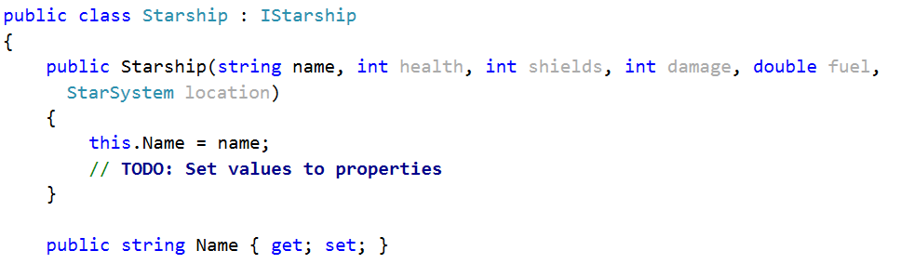

Implement the missing members of that interface (properties, methods). Think about **if the class should be allowed to be instantiated** (tip: **abstraction**). In that sense, should the constructor of Starship be **public**?

Implement concrete classes - **Frigate**, **Cruiser** and **Dreadnought**.

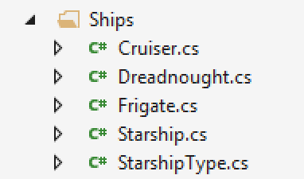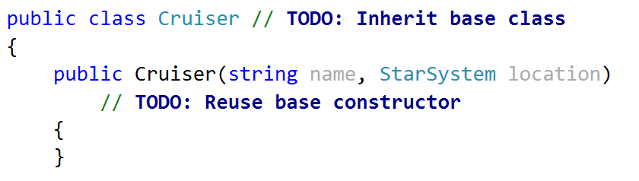

Notice the problem description states that the **Frigate** should also keep **count of all projectiles fired** (we'll talk more about later). For now, just create a field **projectilesFired** in the frigate class for keeping track of all fired porjectiles.

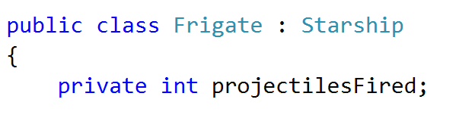

### Step 4 - Implement TODOs in ShipFactory

Now that we have classes for each ship in our game, let's implement the missing parts of the **ShipFactory**.

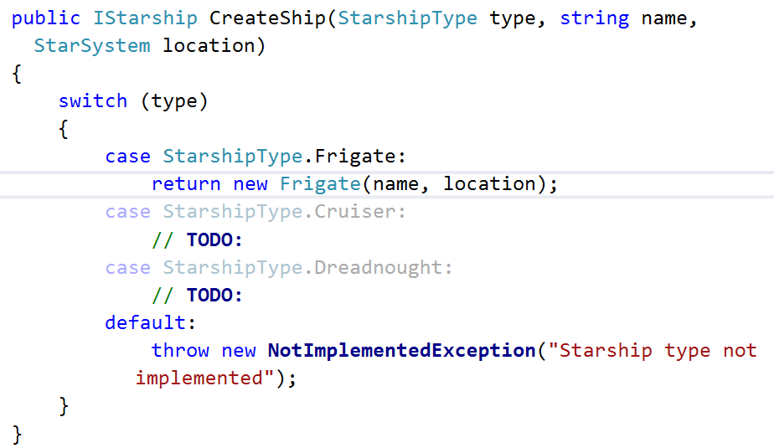

### Step 5 - Create Command

It's time we implemented our first command - **create**. The Commands namespace contains several commands, all of which inherit the base **Command** class. However, there are 3 things wrong with it.

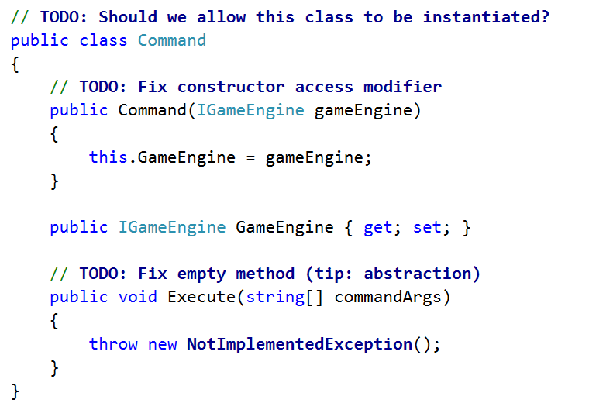

Now that we've fixed the base Command class, it's time we started implementing our concrete commands.

As we already saw, each command's **Execute()** method is called whenever a command string is entered by the user. Obviously, each command class will implement that method differently.

In order for a descendant class to change a method, it needs to **override** it.

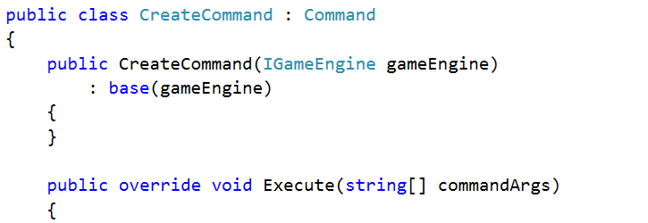

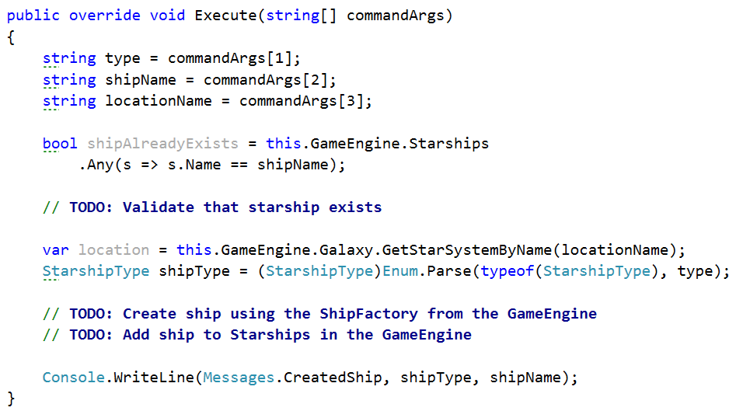

If everything is correct, the **Create** command should successfully create a ship and add it to the Starships collection in the engine.

### Step 6 - Implement AddEnhancement()

The starships we made (**Frigate**, **Cruiser** and **Dreadnought**) inherit **Starship**. Starship implements the **IStarship** interface. **IStarship** extends the **IEnhanceable** (which defines behavior for holding enhancements and adding new ones). Therefore, all ships are **enhanceable**.

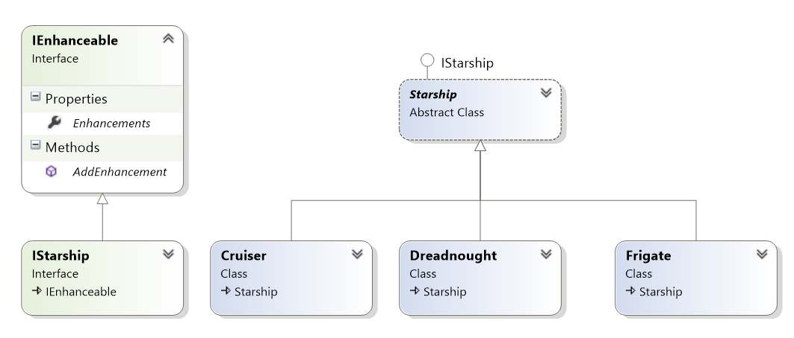

Since all ships are **IEnhanceable**, they have **AddEnhancement()** method.

Judging from the **Create** command, all arguments after the 4th will be enhancements  
(e.g. **create {shipType} {shipName} {starSystem} {enhancement1 enhancements2 ...}**).

Let's go back to the **CreateCommand** class and add enhancements after we've created a ship.

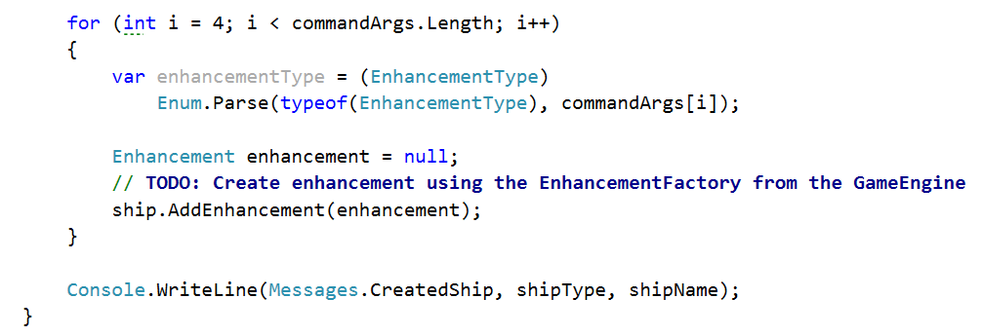

So far so good, but we need to implement the **AddEnhancement()** method. The question is - where? In Frigate? In Dreadnought? No, in **Spaceship** - it is the base class for all ships so each ship will reuse it.

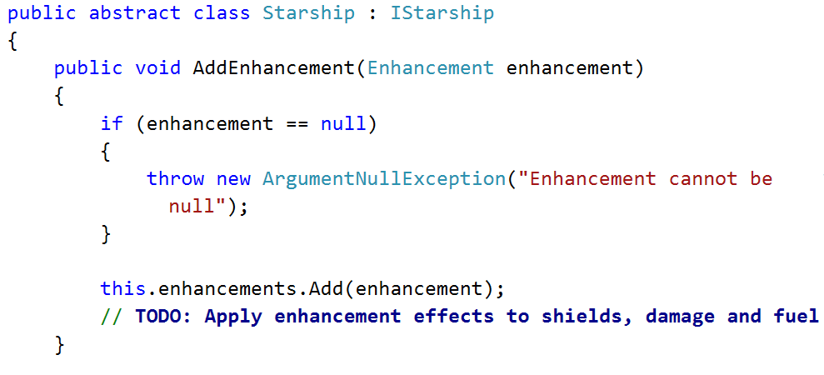

But, **enhancements** is **IEnumerable<Enhancement>**. How do we add an element to an **IEnumerable** collection. We don't.

Internally we keep the enhancements as **private** **IList<Enhancement>** (a collection that allows adding elements) and add to that collection. But we reveal it as **IEnumerable<Enhancement>** (a collection that can only be iterated).

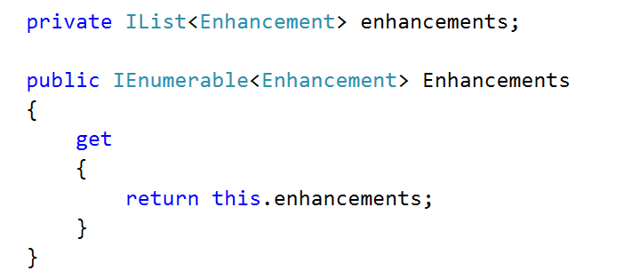

Why is this allowed? Because **IList<T>** extends **IEnumerable<T>** and thanks to **polymorphism** we can reveal a more concrete object as a more abstract one.

**Note:** That way nobody from outside the class can add/remove enhancements, because the collection is revealed as **IEnumerable**. Inside the class, however, we can work with **IList** and we can add/remove elements.

### Step 7 - Status Report Command

Just like **CreateCommand**, **StatusReportCommand** should inherit the base Command class and override its **Execute()** method.

It should print information about a given ship in the following format:

|  |  |
| --- | --- |
| **If health > 0** | **If health <= 0** |
| **--{shipName} - {shipType}**  **-Location: {locationName}**  **-Health: {health}**  **-Shields: {shields}**  **-Damage: {damage}**  **-Fuel: {fuel}**  **-Enhancements: {enh1, enh2, ...}** | **--{shipName} - {shipType}**  **(Destroyed)** |

The format varies depending on the ship's health. Let's implement the command:

1. Inherit the **Command** class
2. Reuse the base constructor to avoid code repetition
3. Override the abstract **Execute()** method:
   * Get the ship from the engine by name
   * Print the ship to the console by calling its **ToString()** method

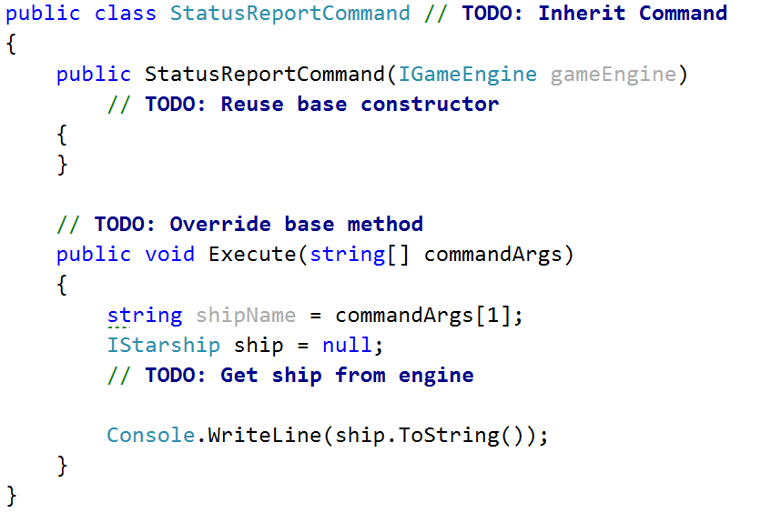

Obviously the ship's **ToString()** method must return information about the ship.

However, by default **ToString()** returns the class' type. We want it to return ship info. Fortunately for us, **ToString()** is a virtual method - therefore we can override it and change its behavior for our needs.

Let's go to the base **Starship** class and override its **ToString()** method. By overriding a method in a parent class, all child classes also inherit the overriden method.

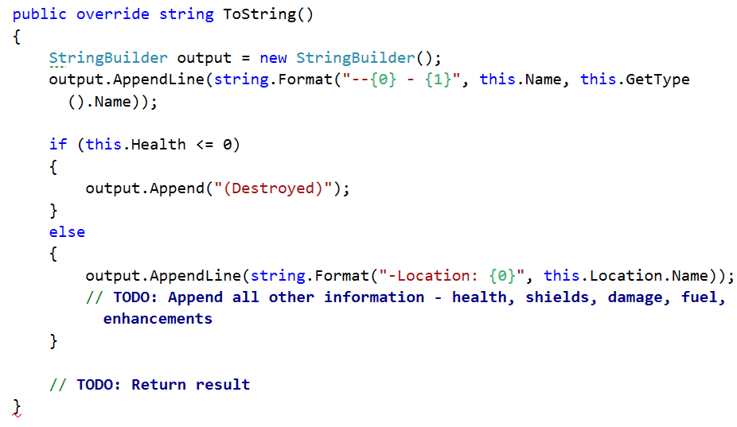

Thanks to **inheritance** the **Frigate**, **Cruiser** and **Dreadnought** classes inherit the above method implementation and we **avoid code repetition**!

However, there is one more thing: If the ship is a **frigate** (and not destroyed), it should also display the number of projectiles fired so far in the format:

|  |
| --- |
| **-Projectiles fired: {count}** |

We need to override the **Frigate's** **ToString()** method too and add that additional line. Make sure you do not repeat any code by reusing the base (Starship) implementation!

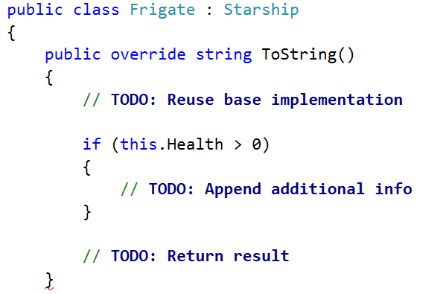

### Step 8 - Attack Command

Time to implement the attack command. Let's go to the **AttackCommand** class and override the **Execute()** method.

1. We get the **attacker ship name** and **target ship name** from the command arguments
2. Then we get the **ships** with those **names** from the engine
3. Finally, we pass the 2 ships to our **ProcessStarshipBattle()** method (notice how it's **private** because there is **no need** for the method to be visible to the outside world)

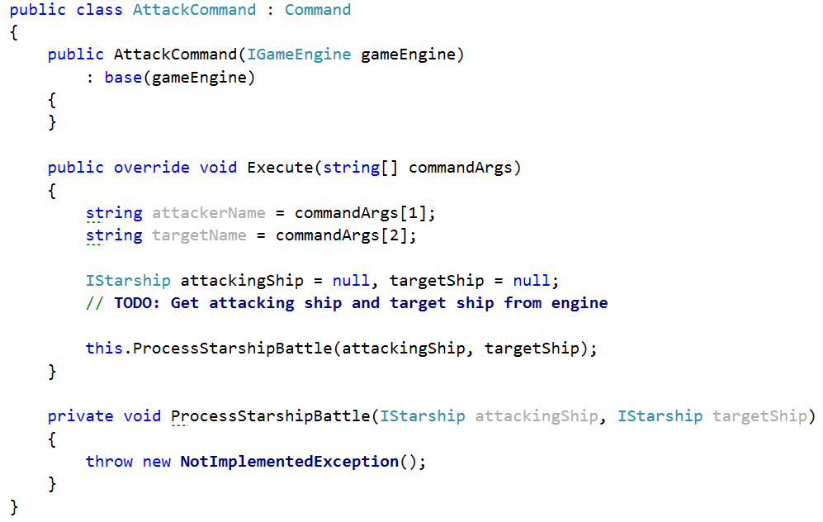

The **ProcessStarshipBattle()** method should do the following things:

1. Validate that the 2 ships have **not been destroyed** (are still alive)
2. Validate the two ships are in the **same star system** (by rules, a ship cannot ships in other star systems)
3. The attacking ship's **ProduceAttack()** method should produce a projectile
4. The target ship should take the projectile using its **RespondToAttack()** method
5. Finally, check if the target ship's health or shields has fallen **below 0** and **raise them back to 0**

First, let's create method that validates whether a ship is alive (not destroyed).

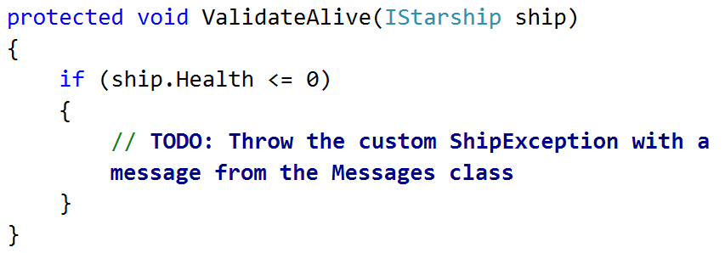

Think about where you should place this method - it will be used by several commands later (not only the **AttackCommand** class).

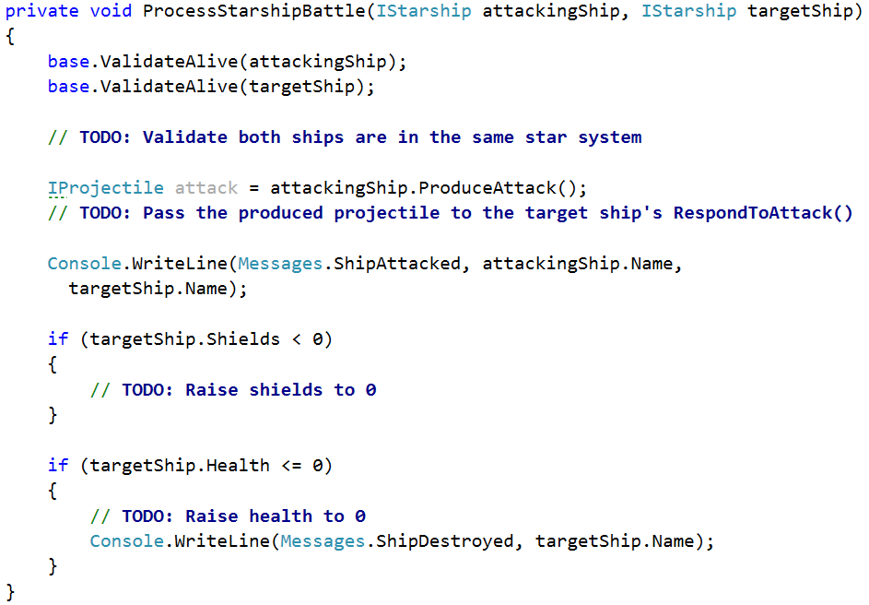

If all is right, the attack command should be ready. But it cannot work correctly until we implement each ship's (Frigate, Cruiser and Dreadnought) **ProduceAttack()** and **RespondToAttack()** methods.

### Step 9 - Implement ProduceAttack()

Every ship has a **ProduceAttack()** method (as defined by the **IStarship** interface). The method's return type is **IProjectile** - this suggests it must return the projectile of the attacking ship. The problem description states that every ship fires a different projectile - **Penetration Shell**, **Shield** **Reaver** or **Laser**. Let's implement the projectiles.

Create a base class **Projectile** and a class for each of the actual projectiles - **Laser**, **PenetrationShell** and **ShieldReaver**.

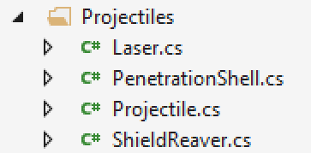

**Projectile** should serve as a **base class** for all projectiles and should **not allow to be instantiated**. It should also implement the **IProjectile** interface.

The interface defines that all projectile should have **damage** (passed by the firing ship) and **Hit()** method.

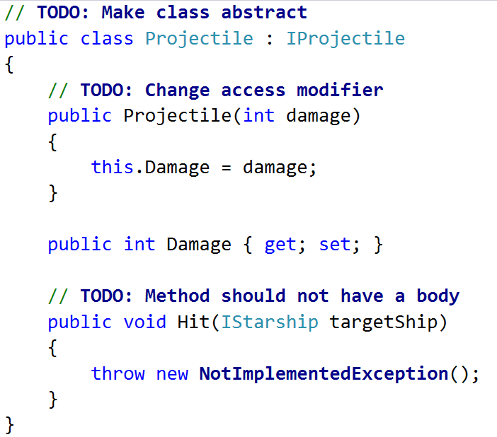

Let's take a look at what each projectile's **Hit()** method should do:

* **PenetrationShell** - removes **health** from the ship equal to the projectile's **damage**.
* **ShieldReaver** - removes **health** from the ship equal to **the projectile's damage**. It also removes **shields** from the ship equal to **2x the projectile's** **damage**.
* **Laser** - removes **shields** from the ship equal to the projectile's **damage**. If the damage is more than the ship's shields, it also takes health equal to the damage left. (e.g. **50 shields** and **100 health** - a laser of **80 damage** would remove **50** shields and **30** health, resulting in **0 shields** and **70 health** for the ship).

Let's start with the **PenetrationShell**:

1. Create a **PenetrationShell** class and **inherit** the **base** **Projectile** class
2. Reuse the base constructor
3. Override the abstract **Hit()** method. It should **subtract health** from the **hit ship** equal to the **projectile's own damage**

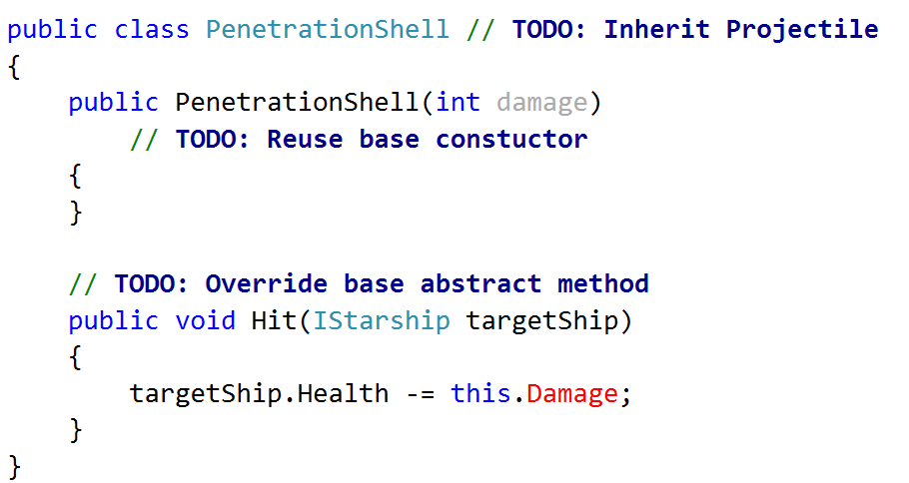

Do the same for each of the other **Projectile** classes - **ShieldReaver** and **Laser**.

Now that we have the projectile's available, it's time we implemented the **ProduceAttack()** method for each of our ships.

|  |  |  |
| --- | --- | --- |
| **Ship** | **Projectile** | **Description** |
| Frigate | PenetrationShell | Shoots a **ShieldReaver** with damage equal to its **own damage**. |
| Cruiser | ShieldReaver | Shoots a **PenetrationShell** with damage equal to its **own damage**. |
| Dreadnought | Laser | Shoots a **Laser** with damage equal to **half its shields + own damage**. |

For example, a **Cruiser** should produce a **PenetrationShell** with damage equal to its own damage.

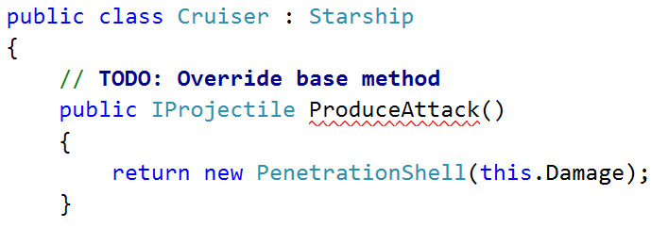

Follow the table above and do the same for other ships as well.

**Hint**: Increase the **projectilesFired** field of Frigates before producing a projectile.

### Step 10 - Implement RespondToAttack()

Let's take a look at how different ships respond to attacks.

|  |  |
| --- | --- |
| **Ship** | **Response** |
| Frigate | None (i.e. they just get hit) |
| Cruiser | None (i.e. they just get hit) |
| Dreadnought | **Raises** its **shields by 50** before getting hit (and removes them after that) |

In other words, the **RespondToAttack()** method of **Frigates** and **Cruisers** should only call the **Hit()** method of the projectile.

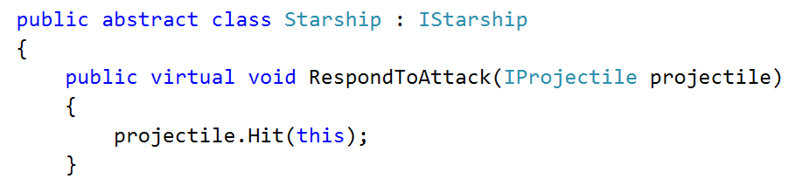

Since this **behavior is common** for the majority of ships, it's safe to extract it to the base **Starship** class. We declare it virtual, so any descendants who wish to change the method should be free to do so.

The only descendant class which responds differently to attacks is the **Dreadnought**.

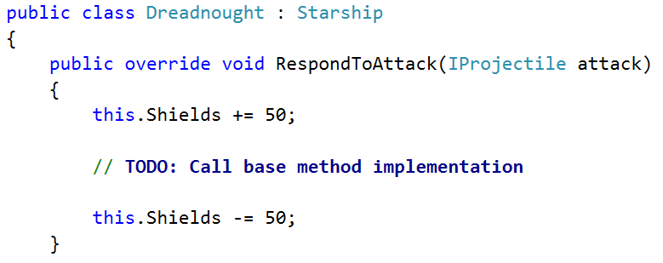

### Step 11 - Plot Jump Command

The command should change the location of the given starship to another star system. The following steps should be taken:

1. Get the **ship** from the engine by name
2. Validate it is not destroyed
3. Get the **destination star system** from the **Galaxy**
4. Validate that the ship is not already in the given destination
5. Call the appropriate method from the galaxy class to perform the travel for you  
   **Hint**: Look through the **Galaxy** class

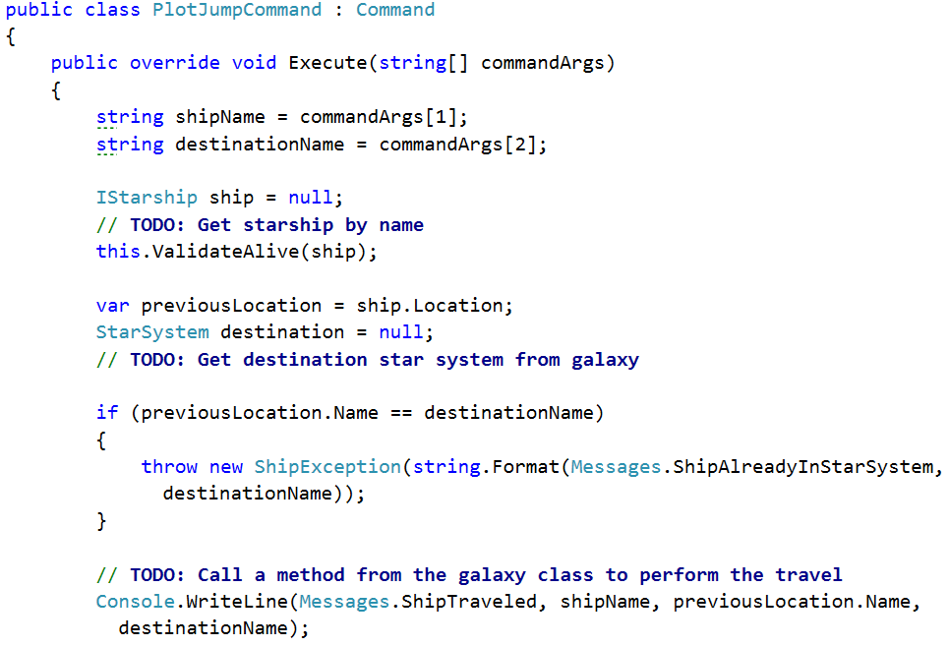

### Step 12 - Over Command

Implementing the **over** command is done like just any other command - we override the **Execute()** method in the **OverCommand** class. This one is up to you - look up the **GameEngine** class and see if there's any property you can change to stop the engine.

### Step 13 - System Report Command

The **system-report** command should print all ships in the given star system. Let's create a new **SystemReportCommand** class (following the naming convention of the other command classes - "**CommandName** + **Command**"). It should inherit the base **Command** class and reuse its constructor.

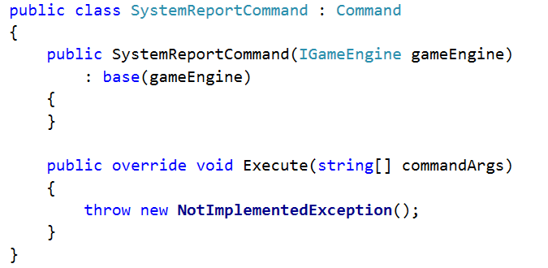

Its **Execute()** method should print information about all ships in the given star system as defined in the description.

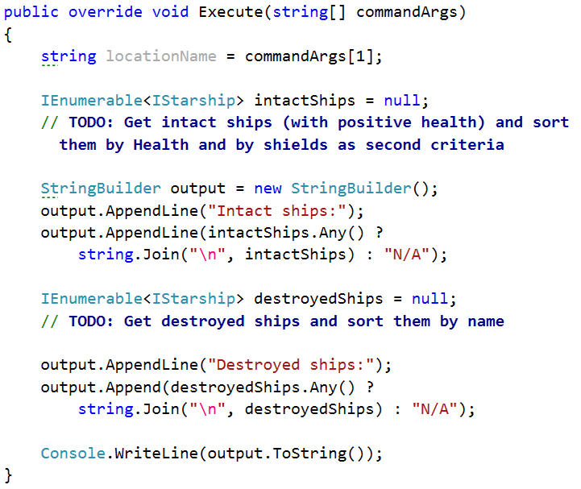

### Step 14 - Extend the Engine

We have our new command class. However, the problem description explicitly tells us we have to extend the game engine **without editing its source code** (following the so-called **Open/Closed Principle** - open for extension, closed for modification).

This is often the case with external libraries - we wish to extend a library's functionality by adding our own code, but the library is already compiled (thus we do not have access to the source code).

One possible way to **extend a class' functionality** is to **inherit the class** and **override the methods** we wish to change. Let's take a look at the **GameEngine** class.

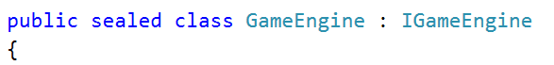

It is declared sealed - therefore it cannot be inherited. But we need to add a new command to the engine - commands are stored in the **CommandManager** class.

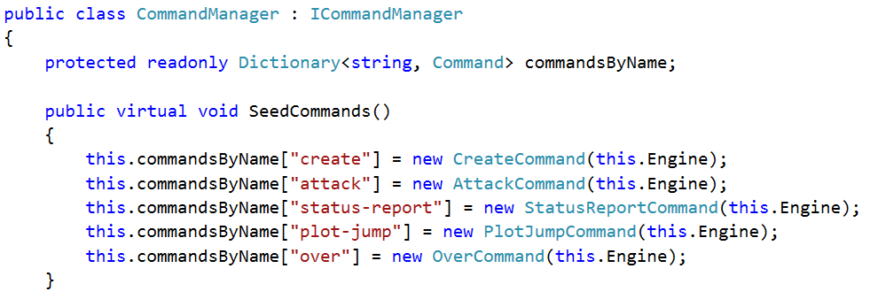

Again, we are not allowed to edit this class (if we were, we would simply add the **system-report** command and be done with it). But if we look closely:

* **SeedCommands()** is left **virtual** (i.e. can be overridden by descending classes)
* **commandsByName** has access modifier **protected** (i.e. can be accessed by descending classes)

Let's create a **ExtendedCommandManager** class that inherits the existing **CommandManager**. The new class should override the **SeedCommands()** method and add the newly created command to the dictionary.

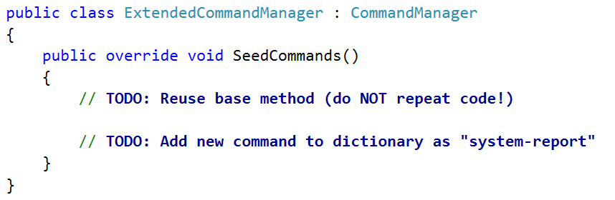

**Note**: Reuse the base method implementation (just like you reuse a base constructor) - do NOT repeat code.

If all is well, the **ExtendedCommandManager** should support all old commands, as well as the newly created SystemReportCommand.

One last thing - we need to change the commandManager instance we pass to the GameEngine in the **Main()** method.

